Start

Set the login cookie for this session

Set the login cookie forever

Is “remember me” checked?

Is the login correct?

Is the login form filled completely?

Display the login form  
“Please fill log in form correctly

No

Yes

Display the error message  
“Username or Password is incorrect”

No

Redirect user back to main page with level access

No

Yes

Yes

|  |  |  |  |
| --- | --- | --- | --- |
| Identifier | Data Type | Description | Example |
| Userid | int(20) | User Identifier, Auto increment | 1.2.3.4.5.6 |
| Username | varchar(100) | Login name | DavidRocksMySocks |
| Password | varchar(100) | Password | HeActuallyDoesnt |
| Level | Int(1) | Level 0 = Non member Level 1 = Member Level 2 = Admin/Teacher |  |
| Email | varchar(100) | Email (needs valid @ address) | Davidasdf@gmail.com |

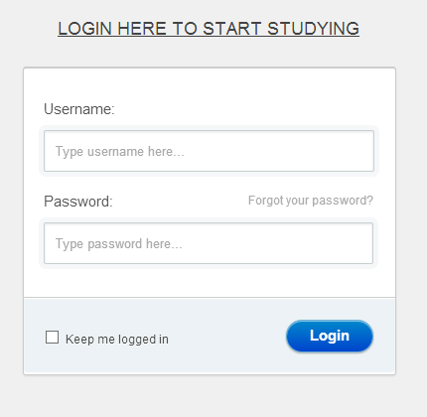

Instructions for user

Placeholder message

Redirects to security Q+A

Login Button

Checkbox for longer log in time

Start  
set username  
set password  
set success = false  
  
REPEAT   
Get usernameEntry  
Get passwordEntry  
  
IF username and password == null  
display no username or password

END F  
else if usernameEntry != username  
display invalid username or password  
else if passwordEntry != password  
display invalid username or password  
else  
display login successful  
!success  
UNTIL success== true  
End

**WHILE**  
**IF (Username == EnteredUsername && Password == EnteredPassword) THEN**  
**Login Successful**  
**ELSE**  
**Login Failed.**  
**ENDIF**